**Lab – 8: Customize user settings in Azure.**

**Objective:** The objective of this lab is –

* To customize user settings in Azure AD for your enterprise.

**Prerequisite:** EMS Enterprise Mobility + Security E5.

**Steps:**

1. Sign in to your Azure Portal, by using the link - **https://portal.azure.com/**. Enter your credentials and click Sign In.

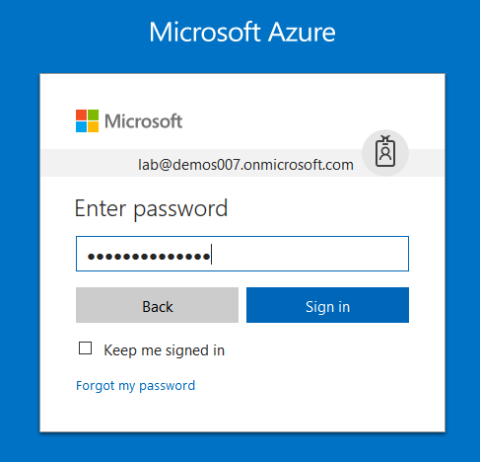

1. Microsoft Azure AD Dashboard will open.

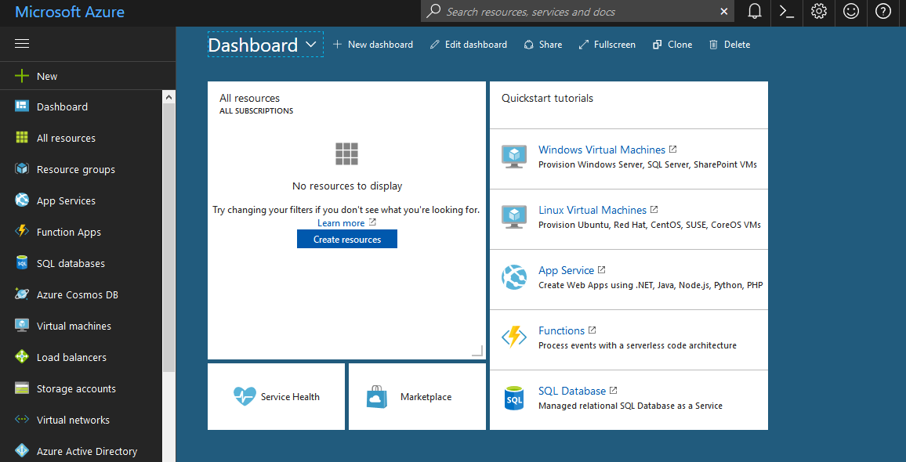

1. Now click **Azure Active Directory** from left-hand pane, and then select **User Settings** in the **Manage** section.

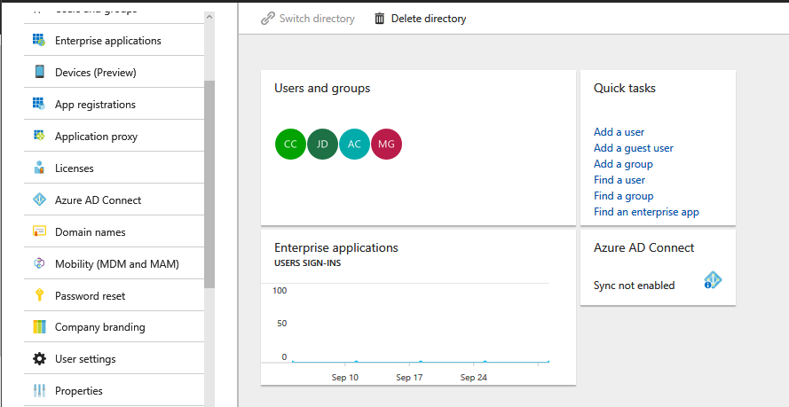

1. Configuration page will open. Here, you will get configuration settings for – Enterprise applications, App registrations, External users and Administration portal.

From **Enterprise applications** section, you can configure –

1. Users can consent to apps accessing company data on their behalf. If this option is set to yes, then users may consent to allow third-party multi-tenant applications to access their user profile data in your directory. This also means that the users will see these apps on their access panels. If this option is set to no, then admins must consent to these applications before users may use them.
2. Users can add gallery apps to their Access Panel. If this option is set to yes, then users may add any app which supports password single-sign on to appear in their access panel, without an admin needing to pre-integrate that application. If this option is set to no, then admins must manually integrate these applications in order for users to see them on their access panels.

From **App registrations**, you can configure –

1. Users can register applications. If this option is set to yes, then non-admin users may register custom-developed applications for use within this directory. If this option is set to no, then only users with an administrator role may register these types of applications.

From **External users**, you can configure –

1. Guest users permissions are limited. Yes, means that guests do not have permission for certain directory tasks, such as enumerate users, groups or other directory resources, and cannot be assigned to administrative roles in your directory. And, no means that guests have the same access to directory data that regular users have in your directory.
2. Admins and users in the guest inviter role can invite. Yes, means that admins and users in the "Guest Inviter" role will be able to invite guests to the tenant. No means they will not be able to invite guests to the tenant.
3. Members can invite. Yes, means that non-admin members of your directory can invite guests to collaborate on resources secured by your Azure AD, such as SharePoint sites or Azure resources. And, no means that only administrators can invite guests to your directory.
4. And, Guests can invite. Yes, means that guests in your directory can themselves invite other guests to collaborate on resources secured by your Azure AD, such as SharePoint sites or Azure resources. And, no means that guests cannot invite other guests to collaborate with your organization.

And, From **Administration portal**, you can configure –

Restrict access to Azure AD administration portal. Here, no lets a non-administrator use this Azure AD administration portal experience to access Azure AD resources that the user has permission to read, or manage resources they own. Yes, restricts all non-administrators from accessing any Azure AD data in the administration portal, but does not restrict such access using PowerShell or another client such as Visual Studio.

So, in this way you can configure User Settings.

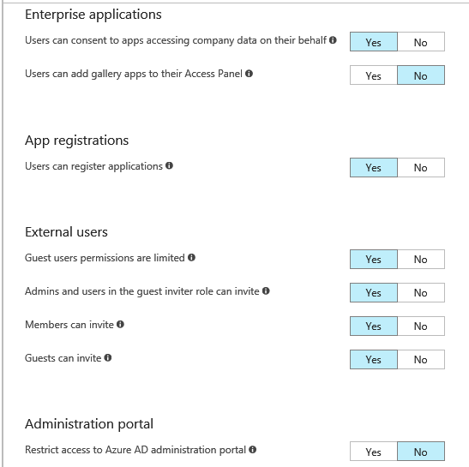

1. Here, we are configuring, **Users can add gallery apps to their Access Panel** under **Enterprise Applications** and **Restrict Access to Azure AD administration portal** under **Administration Portal**.
2. So, select Yes for **Users can add gallery apps to their Access Panel**.
3. And, select Yes for **Restrict Access to Azure AD administration portal**.

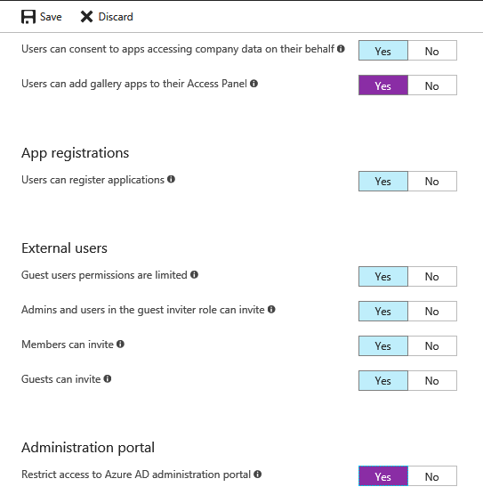

1. Then, click **Save**.



1. After clicking Save, you will get a notification pop-up that **Successfully updated user settings**.

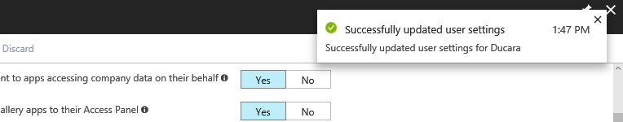

1. So, in this way you can configure User settings in Azure AD for your organization.